# Exercise: Computer Systems and Software – npm, Node.js

Problems for exercises and homework for the ["Software Technologies" course @ Software University.](https://softuni.bg/trainings/4086/software-technologies-may-2023)

## What is it and why you need it

**The NPM** – Node Package Manager is the default package manager for Node.js. **Node.js** is an open-source, cross-platform JavaScript runtime environment that allows developers to build server-side applications using JavaScript. It can also be useful for manual testers when working on a web application that is built using Node.js. Running the application locally and test it in a development environment will require Node.js installed.

## How to install

**0. Prerequisites**

Here's what you need to go ahead with Node.js and NPM.

**Hardware Requirements**

RAM 4GB

CPU Intel Core i3TM i3 HQ CPU @2.50 GHz

**1. Installing via official website**

Navigate to <https://nodejs.org/en/download>

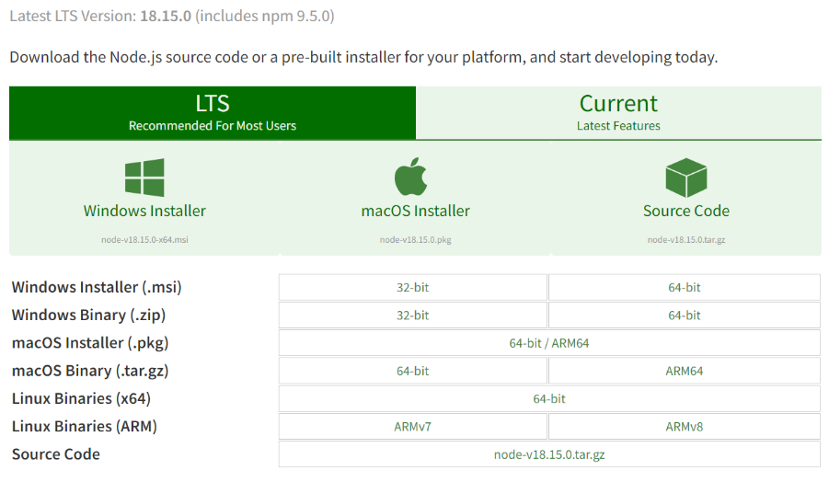

**2.** Choose the **appropriate installer**. Here, we are choosing the 64-bit version of the Node.js installer.

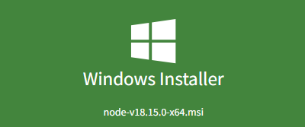

**The LTS (Long-term Support) version is highly recommended** for you. Now .msi file will be downloaded to your browser.

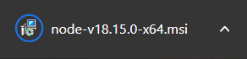

**3.** Double click on .msi binary files to initiate the installation process. You will get a welcome message on your screen and click the "Next" button. The installation process will start.

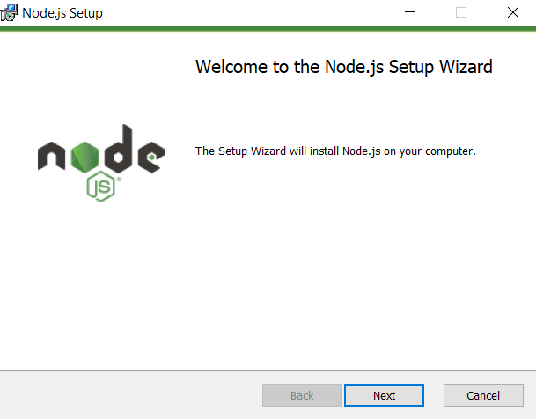

**4. Accept the "Licence Agreement"** and **choose the desired path** where you want to install Node.js.

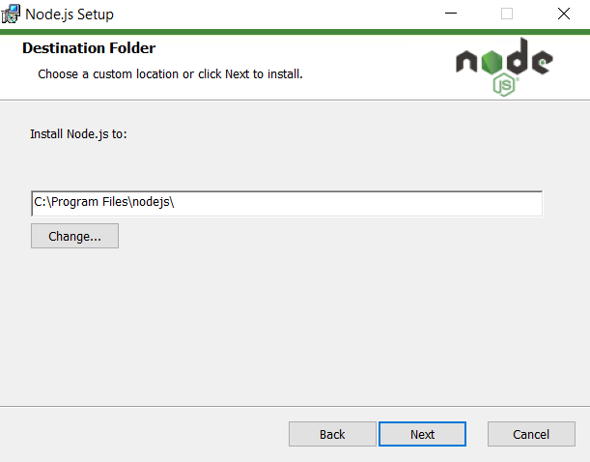

**5.** The following features will be **installed by default:**

Node.js runtime

Corepack manager

Npm package manager

Online documentation shortcuts

Add to Path

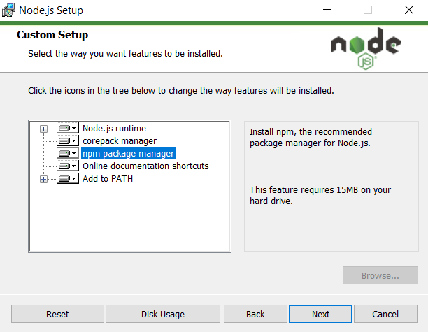

**6.** **Do NOT install** the "Tools for native modules". You won't need them for now. Make sure the pointed option is unchecked.

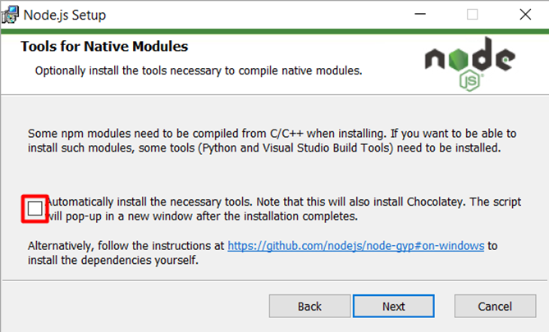

**7. Click Install**

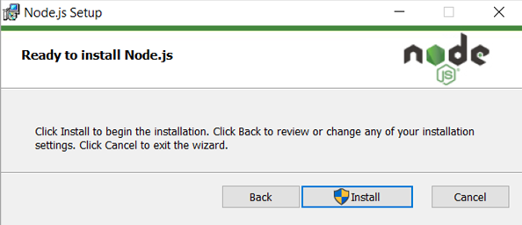

**8.** When **prompted by Windows, give permission to make changes**. Installation now should begin.  
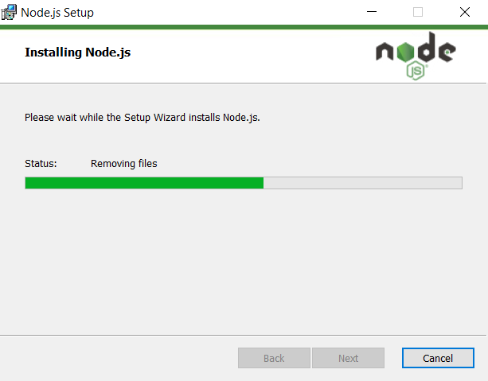

**9. Click Finish** to exit the setup.

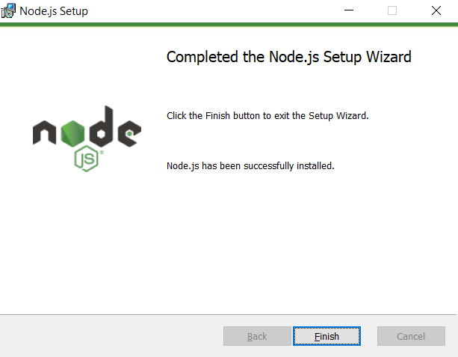

## Check Node.js and NPM Version

To check whether you have installed everything correctly or not, let's verify it with "Command Prompt".

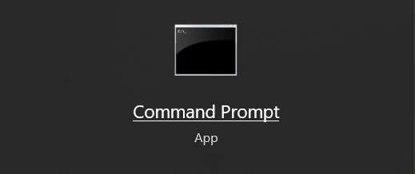

To confirm Node installation, type **node -v** command.

To confirm NPM installation, type **npm -v** command.

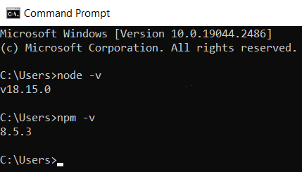

You don’t need to worry if you see different version numbers as Node and NPM are updated frequently.

## Simple expressions

Node.js comes with virtual environment called REPL (aka Node shell). REPL stands for Read-Eval-Print-Loop. It is a quick and easy way to test simple Node.js/JavaScript code.

To **launch the REPL (Node shell)**, open command prompt (in Windows) or terminal (in Mac or UNIX/Linux) and type **node** as shown below. **It will change the prompt to > in Windows and MAC.**

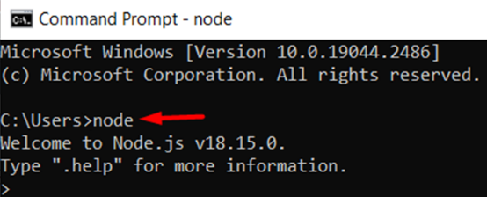

You can now test pretty much any Node.js/JavaScript expression in REPL.

**5 + 10** will display 15 in new line**.**

You can print something, for example **console.log("Hello World!").**

The + operator also concatenates strings as in browser's JavaScript. So **"Hello" + "World!"** becomes 'HelloWorld!'**.**

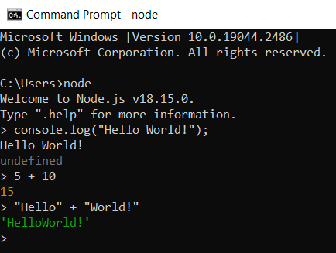

You can also **define variables** and **perform some operation** on them.

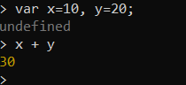

If you need to write multi line JavaScript expression or function then **just press Enter whenever you want to write something in the next line** as a continuation of your code. The REPL terminal will display three dots (...), it means you can continue on next line. Write .**break to get out of continuity mode**.

For example, you can define a function and execute it.

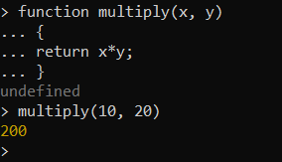

**To exit** from the REPL terminal, **press Ctrl + C twice** or write .exit and press Enter.

